TNE20003 – Internet and Cybersecurity for Engineering Applications

# Portfolio Task – Lab 2 Pass Task

## Aims:

* To subnet a network according to the given class address and network diagram

## Preparation:

* + View [“IP Subnetting"](https://swinburne.instructure.com/courses/54168/pages/ip-subnetting?module_item_id=3692170) & [“IP address and subnetting task-1](https://swinburne.instructure.com/courses/54168/pages/ip-subnetting?module_item_id=3692170)” & “[Network Addressing & Subnetting](https://swinburne.instructure.com/courses/54168/pages/ip-subnetting?module_item_id=3692170)”

## Task Completion

* Upon completion of this task you are to demonstrate and explain your successful subnetting to the lab instructor who will then mark you as having completed this task. Your instructor will ask you some questions to allow you to show the depth of your understanding.

## Due Date:

* All tasks in this lab are to be completed and demonstrated to your Lab instructor preferably during or at the end of the current lab, but if you do not complete the tasks you may demonstrate it at the beginning of your next lab class.

### Subnet and Address a Network According to Provided Requirements

In this task, you will

* Undertake the subnetting needed for the network shown in the diagram below and provide Addressing for each network/subnetwork in that diagram.

### Instructions

1. Using the examples provided in the documents under the tutorial section under modules on Canvas for this unit, carry out the relevant subnetting to completely address the network shown below.

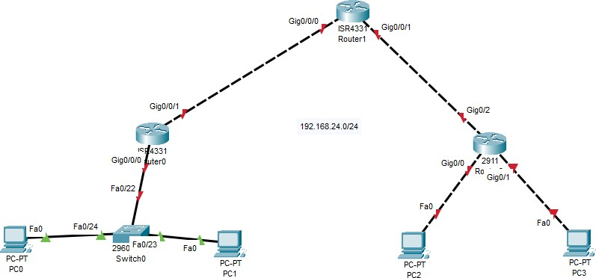

200.200.100.0/25

Some things you may want to consider are:

* + What class of network is the given address?
  + How many networks do I have in the diagram?



* + How many host addresses do I need per network/subnetwork?

WORKING OUT

1. The given address belongs to the class C network. The first octet is 200 which falls in the range of 192-223 which is class C. The default subnet mask of class C is 255.255.255.0 or 24 bits for the subnet address and other 8 bits for the host address. However, in this address the subnet mask is 200.200.200.0/25
2. There are 5 networks in this diagram. Connection from Router 1 to Router 0, Router 0 to switch 0, Router 1 to Router 2, Router 2 to PC2, Router 2 to PC3.
3. 2 host addresses will be needed per subnetwork.

We have 5 networks but not enough subnet masks. To cover all the networks, we need to borrow 3 bits from the host network. As a result, we have 4 bits for host addresses and 4 bits for subnet.

We cannot use the subnets with all 0’s or 1’s in the host address. Subnets are:

200.200.100.0 (Network id)

200.200.100.16

200.200.100.32

200.200.100.48

200.200.100.64

200.200.100.80

200.200.100.96

200.200.100.112 (Broadcast Id)

We can use these subnet masks to define all the 5 networks.

Available host addresses fall within the Ranges:

200.200.100.1-14 inclusive

200.200.100.17-30 inclusive

200.200.100.33-46 inclusive

200.200.100.49-62 inclusive

200.200.100.65-78 inclusive

200.200.100.81-94 inclusive

200.200.100.97-110 inclusive

# Portfolio Task – Lab 2 Credit Task

## Aims:

* Using the addressing you carried out in the Pass Task of this lab you must build and implement an addressed network according to the given network diagram below on Packet Tracer (PT)



200.200.100.192/26

## Preparation:

* + View “[TNE20003 Lab1-P_Student](https://swinburne.instructure.com/courses/54168/assignments/567094)” for instruction on Packet Tracer implementation.

## Task Completion

* Upon completion of this task you are to demonstrate your network implemented on PT. Your lab instructor will then mark you as having completed this task. Your instructor will ask you some questions to allow you to show the depth of your understanding.

## Due Date:

All tasks in this lab are to be completed and demonstrated to your Lab instructor preferably during or at the end of the current lab, but if you do not complete the tasks you may demonstrate it at the beginning of your next lab class.

# Portfolio Task – Lab 2 Distinction Task

## Aims:

* Demonstrate successful end-to-end connectivity of the addressed network implemented in Packet Tracer from the Credit Task above.

## Preparation:

* + Using Self-Directed learning find out about static routes
    - What are they?
    - What are they used for?
    - How do you implement them?
    - Which device(s) are they placed on?
  + Static routes are vital for you to be able to achieve end-to-end Connectivity.

## Task Completion

* Upon completion of this task you are to demonstrate and explain your successful implementation of static routes to the lab instructor who will then mark you as having completed this task. Your instructor will ask you some questions to allow you to show the depth of your understanding.

## Due Date:

All tasks in this lab are to be completed and demonstrated to your Lab instructor preferably during or at the end of the current lab, but if you do not complete the tasks you may demonstrate it at the beginning of your next lab class.

*~~~~~ End of Lab ~~~~~*